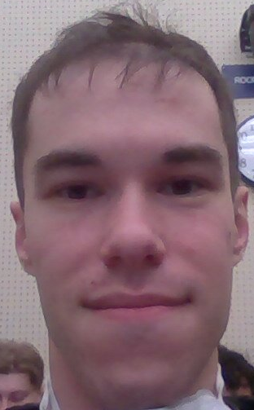
Sean Shekhtman
Student #: 1008305371
UTORID: schekhtm
Outlook: sean.shekhtman@mail.utoronto.ca

I’m Sean Shekhtman! A friendly guy who enjoys going (very) deep into
things, and so I may be a bit slow at times. Once I’m satisfied, I begin my
work at a break-neck pace! I’ve worked with a few open-source projects
here and there, during my free time. I enjoy helping people understand
concepts (perhaps I’ll make for a good TA once I work up the courage
to enlist as one!) and bouncing different ideas to look for the most efficient (though perhaps not the most readable) solutions. My favourite programming language is C, as I find it to be the easiest to debug and maintains a close relationship with the hardware. As you can tell, I’m a pretty low-level guy, so things like Java or CSS may take me some time to get used to. Looking forward to working with my group!

